Erasmus+ Learning Programme for Group Activities
Timetable
Timing | Activity/Session
Day 1(07.05.2023) | Arrival in the host country,
Day 2(08.05.2023)  Session 1  Time: 08:40-12:40  Session 2  Time:13:25-15:45 | -Opening ceremony. Welcome ceremony.  -Breakfast invitation from our school.  -Presentation of the Participants,  -Promotional Video Shows of Participating Countries  -School Tour  - Visiting the local herbalists in Kemeraltı
Day 3(09.05.2023)  Session 1  Time: 08:40-12:40  Session 2  Time:13:30-17:20 | -8.40am Departing from the school to Ephesus by bus.  -10.00 am Arrival to Ephesus  -10:00-12.30 a.m Visiting Ephesus and Virgin Mary  -12:30-13:30 Packed Lunch Break  -14:30-15:30 a.m Visiting Şirince Village where you can regional and organic products.  -15:30 Departure to İzmir  -17:00 Arrival to İzmir
Day 4 (10.05.2023)  Session 1  Time: 08:40-15:45 | -08:40 a.m Departing from school to Urla.  -10.00 a.m Arrival to Urla  -10:00- 12:00 p.m Visiting the Olive Oil Museum and workshop(lamp making)  -12:00-13:30 Packed lunch break  -13:30-14:30 Walk by the sea  -14:30-15-45 p.m Back to School
Day 5 (11.05.2023)  Session 1  Time: 08:40-12:40  Session 2  Time:13:25-15:45 | 8.40am Departing from the school to Bornova.  -9.30 am Arrival to Bornova  -10:00- 11:00 Visiting ‘’Ege University Botanical Garden-Herbarium Application and Research Center’’  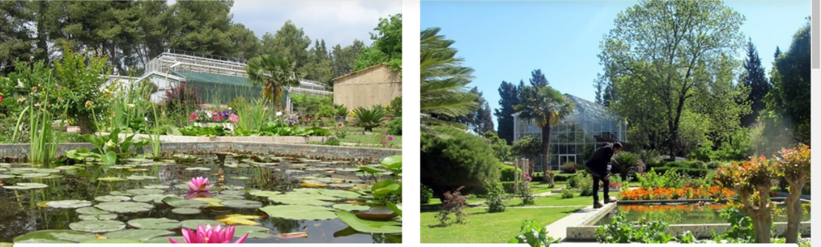  The main purpose of the center is; conduct scientific research in various fields related to plants and vegetation in Turkey, to protect plants that are endangered, seed catalogs and dry herbarium samples to students by increasing the diversity of seeds making the change and the public to introduce them. In the center, there are parts such as plant sales, herbarium, pools and protection garden.  -12:00-13:00 p.m Visit to Can Yücel Seed Center  -13:00-13:30 Back to School  -13:30-15:45 p.m Preparing health snacks and drinks (Masterchef competition)  Giving participation certificates
Day 6 (12.05.2023) | Departure

